**LAB XY - Part 1**

Create this dual oscillator “pad” inspired synthesizer using the file “LabXY - make a pad- DEMO.maxpat”. Take note that the patch and video breaks down the building process into several steps, but the image below is what your final patch should look like.

**Due: turn in a screenshot of your finished patch and name it as follows: “lastname firstname lab XY part 1”. Please also include a comment with your name in the patch.**

Lab XY Part 1 Video link:

Follow the video demonstration and the extensive comments within the patch to guide you to make the patch pictured below.

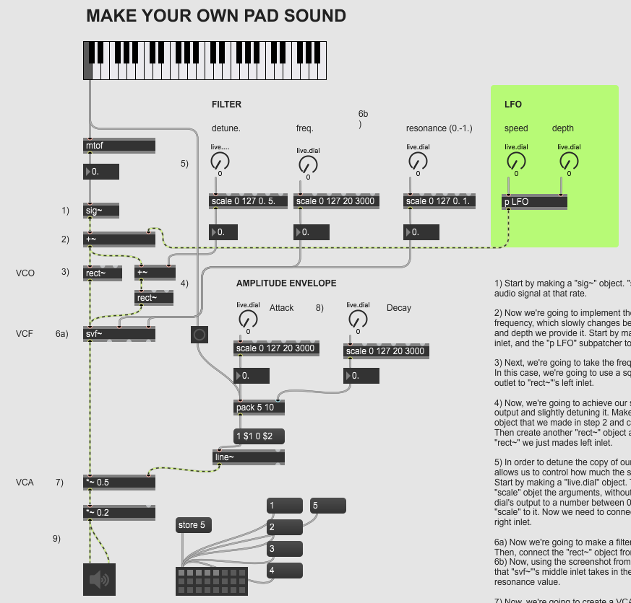

**LAB XY - Part 2**

Create this “supersaw” synthesizer that makes use of several saw oscillators in parallel using the file “LabXY-supersaw-DEMO.maxpat”. Take note that the patch and video breaks down the building process into several steps, but the image below is what your final patch should look like.

**Due: turn in a screenshot of your finished patch and name it as follows: “lastname firstname lab XY part 2”. Please also include a comment with your name in the patch.**

Lab XY Part 2 Video link:

Follow the video demonstration and the extensive comments within the patch to guide you to make the patch pictured below.

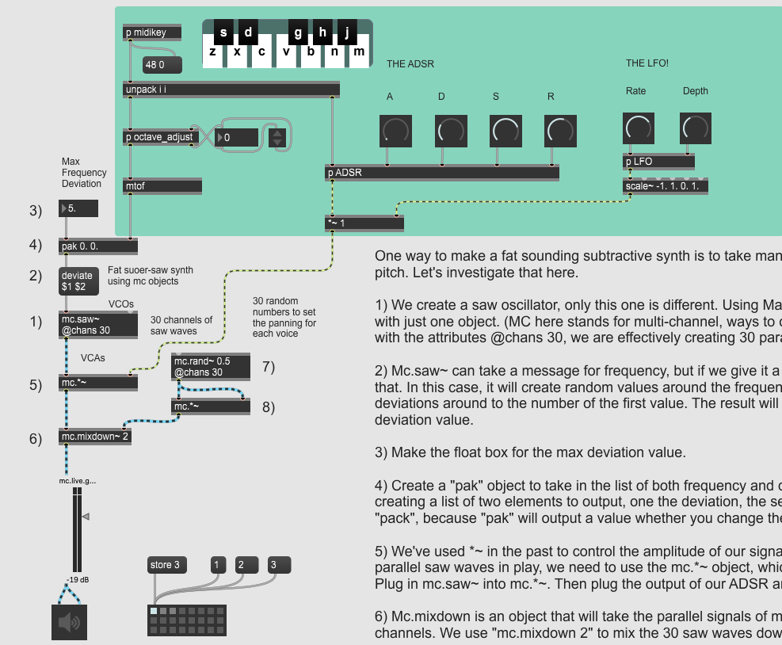

**LAB XY - Part 3**

**Due: Submit the two screenshots from parts 1 & 2**

**Push Goal -** Create a short (roughly 24 beat) musical example in Ableton Live with at least 3 tracks, using the “supersaw” and “pad” synths at least once. You don’t need to program Max4Live versions of these instruments because they’ve already been provided in the “LAB XY - Max4Live” folder. Import them into Ableton Live like you have in the past, and submit your completed WAV file.